# SKILL / JOB RECOMMENDER APPLICATION

## A PROJECT REPORT

*Submitted by*

### A.VISALA ATHIDYA(310519205050) - LEAD

### S.BALAJI (310519205007) - Member

### G.SRIDEVI (310519205041) – Member

### V.VASANTH (310519205048) - Member

For the project

### HX8001 PROFESSIONAL READYINESS FOR INNOVATION EMPLOYABLITY AND ENTREPRENEURSHIP



In the department of

# INFORMATION AND TECHNOLOGY

## DHANALAKSHMI SRINIVASAN COLLEGE OF ENGINEERING AND TECHNOLOGY

### ANNA UNIVERSITY : CHENNAI 603104

**NOVEMBER:2022**

# BONAFIDE CERTIFICATE

Certified this Report “SKILL / JOB RECOMMENDER APPLICATION”, for the project, is the bonafide work of “A.VISALA ATHIDYA (310519205050) ,S.BALAJI(310519205007)

G.SRIDEVI (310519205041),V.VASANTH(310519205048)

who carried out the project work under my supervision. Certified further that to the best of my knowledge the work reported here in does not form part of any other thesis or dissertation on the basis of which a degree or award was co-offered on the earlier occasion on this or any other candidate.

**SIGNATURE SIGNATURE**

**DR.P.PON ARIVANANTHAM DR.R.IDAYAYHULLA**

**(HOD/I.T) (MENTOR)**

FACULTY EVALUATOR INDUSTYRY MENTOR

DR.P.PON ARIVANANTHAM KRISHNA CHAITANYA

( **HOD /I.T) (TEAM)**

# ACKNOWLEDGEMENT

First and foremost, we praise and thank **“The Almighty”**, the Lord of all creations who by his abundant grace has sustained us and helped us to complete this project successfully.

At this pleasing moment of having successfully completed our project, we wish to convey our sincere thanks and gratitude to the management of our college **Prof. P.MANI.,** who provided all the facilities to us.

We would like to express our sincere thanks to our Principal **Dr. R. SARAVANAN., M.E., Ph.D.,** for forwarding us to do our project and offering adequate duration in completing our project.

We extend our whole hearted thanks and gratitude to the Head Of the Department and Mentor **Dr. P.PON ARIVANANTHAM ., M.E., Ph.D.,** for her constructive suggestions and encouragement during our project.

# ABSTRACT

The Internet-based recruiting platforms become a primary recruitment channel in most companies. While such platforms decrease the recruitment time and advertisement cost, they suffer from an inappropriateness of traditional information retrieval techniques like the Boolean search methods. Consequently, a vast amount of candidates missed the opportunity of recruiting. The recommender system technology aims to help users in finding items that match their personnel interests; it has a successful usage in e-commerce applications to deal with problems related to information overload efficiently. In order to improve the e-recruiting functionality, many recommender system approaches have been proposed. This article will present a survey of e-recruiting process and existing recommendation approaches for building personalized recommender systems for candidates/job matching.

**Key words:** Recommender systems, collaborative filtering, content-based filtering, hybrid approach, machine learning, e-recruiting, similarity measure.

# SKILL/ JOB RECOMMENDER APPLICATION TABLE OF CONTENTS

|  |  |  |
| --- | --- | --- |
| **CHAPTER** | **TITLE** | **PAGE NO.** |
| **NO.** |  |  |
|  | **ABSTRACT** | **iv** |
|  | **LIST OF FIGURES** | **vii** |
|  | **LIST OF TABLES** | **viii** |
| **1** | **INTRODUCTION** | **1** |
|  | 1.1 Project Overview | 1 |
|  | 1.2 Purpose | 1 |
| **2** | **LITERATURE SURVEY** | **2** |
|  | 2.1 Existing problem | 2 |
|  | 2.2 References | 2 |
|  | 2.3 Problem Statement Definition | 4 |
| **3** | **IDEATION & PROPOSED SOLUTION** | **5** |
|  | 3.1 Empathy Map Canvas | 5 |
|  | 3.2 Ideation & Brainstorming | 6 |
|  | 3.3 Proposed Solution | 7 |
|  | 3.4 Problem Solution fit | 9 |
| **4.** | **REQUIREMENT ANALYSIS** | **10** |
|  | 4.1 Functional requirement | 10 |
|  | 4.2 Non-Functional requirements | 11 |

### PROJECT DESIGN 12

* 1. Data Flow Diagrams 12
  2. Solution & Technical Architecture 17
  3. User Stories 19

### PROJECT PLANNING & SCHEDULING 21

* 1. Sprint Planning & Estimation 21
  2. Sprint Delivery Schedule 22
  3. Reports from JIRA 22

### CODING & SOLUTIONING 23

* 1. Feature 1 23
  2. Feature 2 29

### TESTING 32

* 1. Test Cases 32
  2. User Acceptance Testing 32

### RESULTS 35

* 1. Performance Metrics 35

### ADVANTAGES AND DISADVANTAGES 36

### CONCLUSION 39

### FUTURE SCOPE 40

### APPENDIX 41

* 1. Source code 41
  2. GitHub & Project Demo Link 48

**LIST OF FIGURES**

### FIG.NO FIG.NAME PAGE.NO

**2.3.1 Customer Problem Statement 4**

### 3.1.1 Empathy Map Canvas 5

* + 1. **Brainstroming 1 6**

### Brainstroming 2 7

**5.1.1 Data Flow Diagram 12**

### 5.2.1 Solution and Technical

**Architecture 18**

**6.3.1 Reports from JIRA 22**

# LIST OF TABLES

### TAB.NO TAB.NAME TAB.PAGE

### 3.3.1 Proposed Solution 8

### 4.1.1 Functional requirements 10

### 4.2.1 Non-functional requirements 11

### 5.2.1 Components and Technologies 19

### 5.3.1 User Stories 20

### 6.1.1 Sprint planning and estimation 21

### 6.2.1 Sprint delivery schedule 22

**CHAPTER – 1 INTRODUCTION**

### Project Overview

When the whole world is coming back on its feet, those businesses affected by this pandemic disease slowly tries to gain back the momentum it lost. Now is the time when the companies or businesses seek to invest in human resources, which would help them to gain the momentum it lost during this period. When the governments across the world ask businesses to halt the operation in the effort of controlling the pandemic, many companies asked their employees to work remotely. In contrast, many other companies started to reduce their operational cost by terminating employees who were in permanent and contract roles. Individuals who lost their job to the consequence of shutdown are a waiting for their next opportunity. Naturally, we human tries to strive through all difficulties to serve the purpose of our life. A daily job provides a sense of purpose to an individual (stillman, 2019), and hetries to get better at it, which results in leaving current employment and looking for a new one; this is a constant cycle of the hiring process.

### Purpose

To serve the constant cycle of the hiring process in the job applicant’s perspective, many job companies have come up with solutions for providing the job board. Here a seeker look’s up for the job he would find relevant to him and apply for it. As there are many job boards, applicants tend to use the tool that provides better services to them, services such as writing a CV, creating a job profile, and recommending new jobs to a job seeker.

Job applicants have become more persistent and proactive in searching for new opportunities that fit their skills. However, companies that are targeting these job seekers are finding it challenging to identify the job seeker’s skill and provide personalized job recommendation

### CHAPTER – 2 LITERATURE SURVEY

* 1. **Existing Problem**
     1. Cannot Upload and Download the latest updates.
     2. No use of Web Services and Remoting.
     3. Risk of mis-management and of data when the project is under development.
     4. Less Security.
     5. No proper coordination between different Applications and Users.
     6. Fewer Users – Friendly.

### References

Many papers have studied to know the details about skill based job recommender system and other techniques can be involved. Here, explain the development techniques of each paper.

### Review 1

**Title:** Using online vacancies and web survey.

**Journal:** Journal of Labour Economics.

**Author:** L.M. Kure Kova

With the widespread access and use of Internet and increased knowledge in digital literacy, posting and searching for job vacancies replaced the traditional methods of job searching. Online job portals are websites that provide for announcing job positions and make it possible to find job vacancies at your fingertips. They are aggregation of job vacancies from companies and resume of various applicants. It serves as a way for posting, searching, selection of applicants applying to the advertise jobs.

### Review 2

**Title:** Organization and end user information system job market.

**Journal:** Learning and Performance Journal.

**Author:** C.Chao, S.Shih.

“Online job vacancy portals contain job offers for almost alloccupations and skill levels. These platforms are a rich source of information about the skills and other job qualifications which are difficult to gather via traditional methods”. They are potential data source for the analysis of labor

market demand that is to identify, analyze and track skills requirements inthe labor market.

### Review 3

**Title:** Skills in demand for ICT and statistical occupation.

**Journal:** The ASA Data science Journal.

**Author:** P.G. Lovaglio.

The data published on online job advertisement websites has been increasingly significant area of research. Online job portals provides a platform on which demand and supply meet which could inform policy makers enabling cross-country comparisons.

### Review 4

**Title:** Online job search and matching quality.

**Journal:** Ifo Working Papers.

**Author:** C.Mang.

The need for graduates with current skill set is of constant concern. Due to the growth and rapid expansion of the IT sector and the introduction of new technologies it resulted in an abundance of job titles which requires current skill requirements. Hence, the skills of IT professionals need to be updated and by doing so it must requires skills that are on demand.

### Review 5

**Title:** Online job vacancies data as a source for micro level analysis of employers.

**Journal:** First International Conference on Public Policy.

**Author:** L. Kure Kova.

With the changing job trends, IT professionals have better employment packages and job opportunities due to high demand for their knowledge and skills. The technological job skill needs of business and industry are continually evolving, which presents a challenge to educators and students attempting to focus on the right skills to meet these changing needs.

### Problem Statement Definition

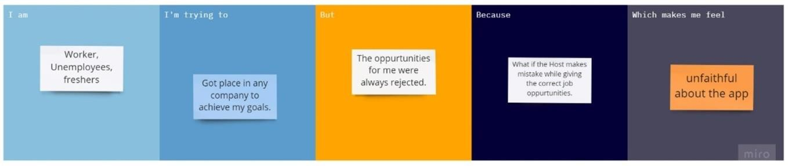

Figure 2.3.1 Customer Problem Statement Template

Reference: https://miro.com/app/board/uXjVPSMP

### CHAPTER – 3

**IDEATION & PROPOSED SOLUTION**

In this Phase the Planning and Project designing of the application were performed. The Ideation and Proposed solution performs, How the Customer got problems and how they overcome the problems were analyzed.

### Empathy Map Canvas

An empathy map is a collaborative tool teams can use to gain a deeper insight into their customers. Much like a user persona, an empathy map can represent a group of users, such as a customer segment. The empathy map was originally created by Dave Gray and has gained much popularity within the agile community.

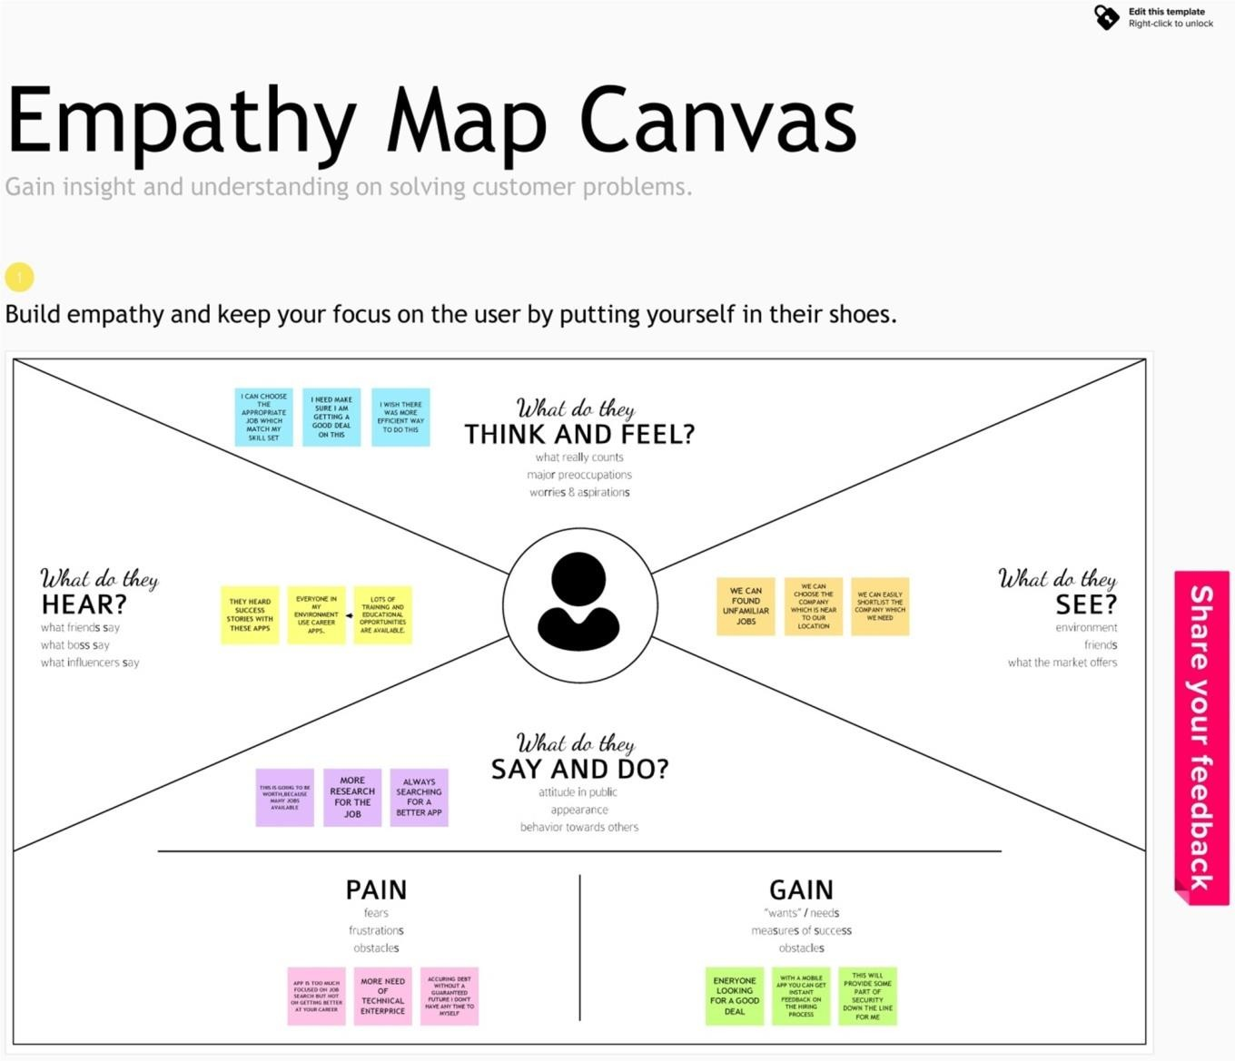

Figure 3.1.1 Empathy Map Canvas

### Ideation & Brainstorming

Brainstorming is a group problem-solving method that involves the spontaneous contribution of creative ideas and solutions. This technique requires intensive, freewheeling discussion in which every member of the group is encouraged to think aloud and suggest as many ideas as possible based on their diverse knowledge.

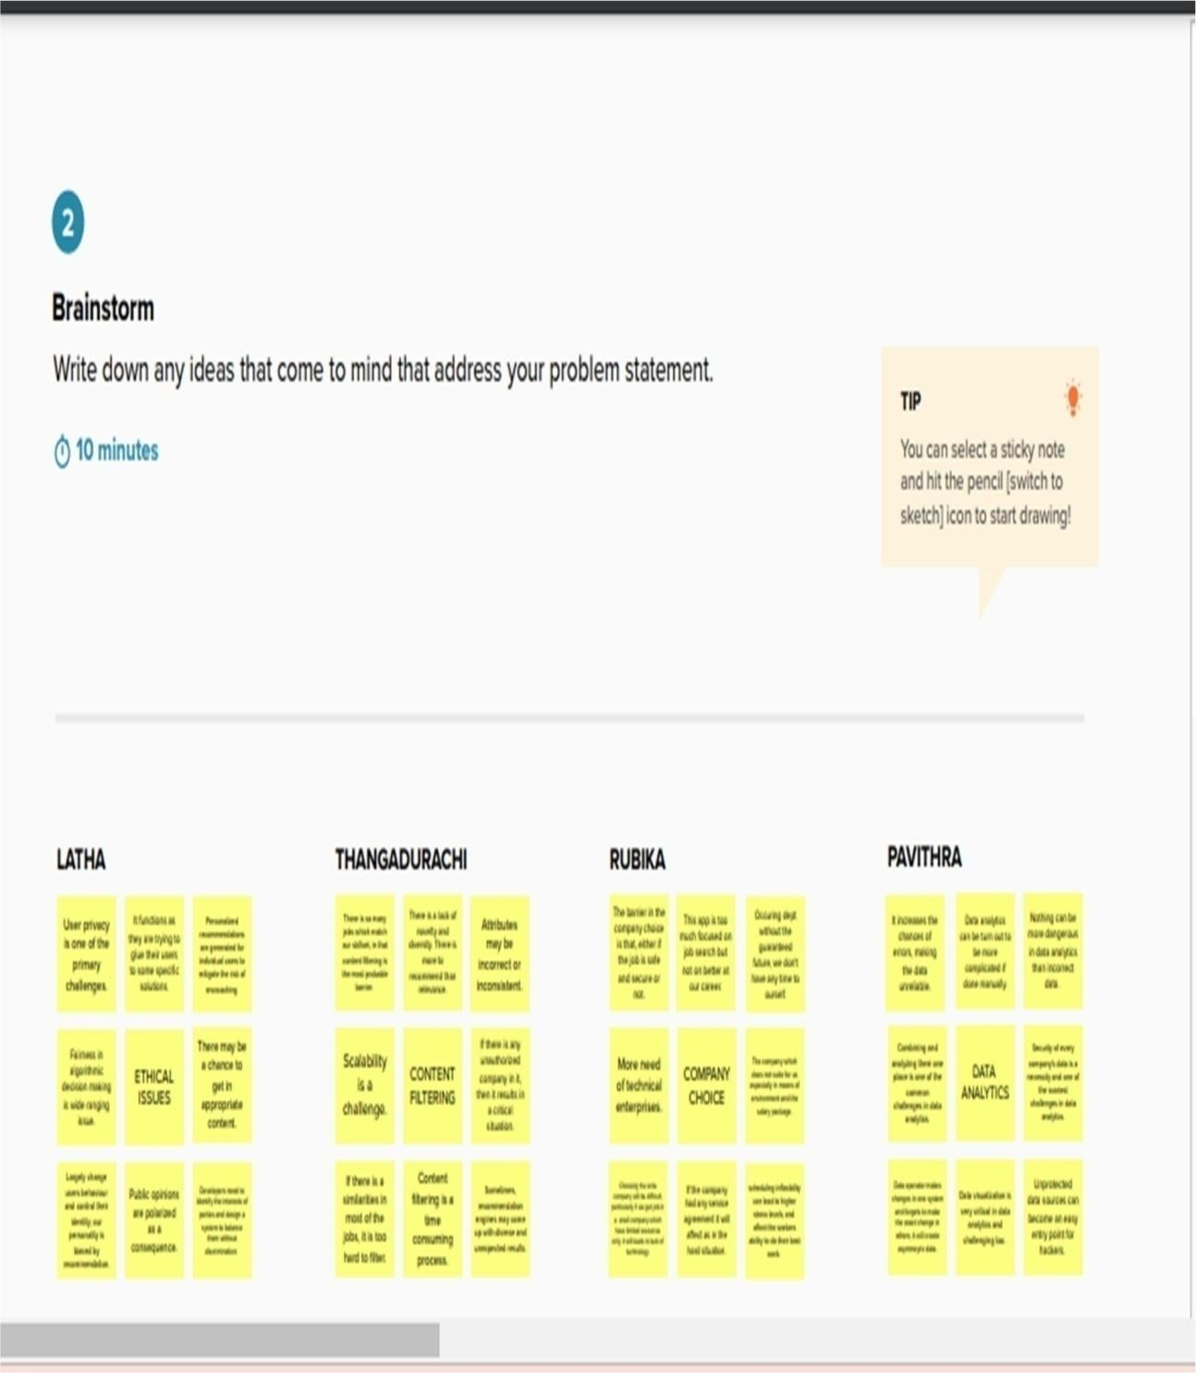

Figure 3.2.1 Brainstroming 1

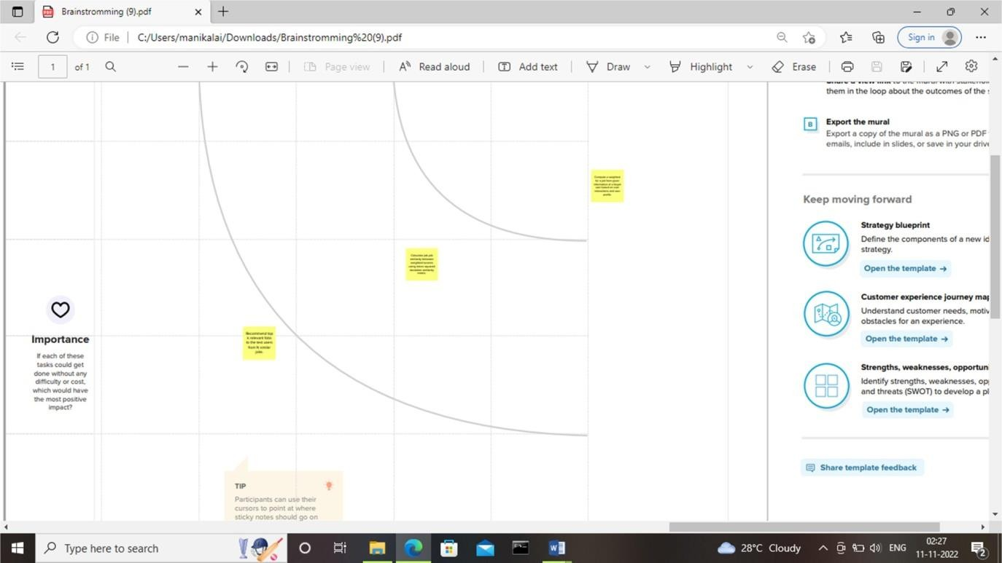

Figure 3.2.2 Brainstroming 2

### Proposed Solution

Our proposed solution should relate the current situation to a desired result and describe the benefits that will accrue when the desired result is achieved. So, begin your proposed solution by briefly describing this desired result.

|  |  |  |
| --- | --- | --- |
| **S. No** | **Parameter** | **Description** |
| 1. | Problem statement(problem to be solved) | Users with unique preferences and tastes that make it difficult to develop accurate profiles. |
| 2. | Idea / Solution  description | It can be solved by proposing a novel  collaborative filtering approach. |
| 3. | Novelty /  Uniqueness | Professional networking is the primary identity of this job recommender system;  it is different from other social media platforms. |
| 4. | Social Impact / Customer  Satisfaction | It helps users in finding jobs that match their personnel interests. |
| 5. | Business Model (Revenue Model) | The core features are provided for free, but the company charges money for  extended features to recruiters as well as job seekers to aid job search. |
| 6. | Scalability of the  Solution | The performance and the accuracy can  be improved by the novel collaborative filtering approach. |

Table 3.3.1 Proposed Solution

* 1. **PROBLEM SOLUTION FIT:**

|  |  |  |  |  |
| --- | --- | --- | --- | --- |
| **CUSTOMER STATE**  **FIT:**  To explore our product to customer, what can we make for them, and how it suitable for them. |  | **CUSTOMER**  **LIMITATIONS:**  The application provides the details about the jobs available for the required skill set. If the skills set doesn’t match any job.we can’t found. |  | **AVAILABLE SOLUTIONS**:  To solve the distance maintenances problem only one solution is there, which is to create and implement our application to all over India |

|  |  |  |  |  |
| --- | --- | --- | --- | --- |
| **PROBLEMS & PAINS:**  The main problem for the application is to maintain the user level, because the user only applied for job recommendation, if every user register in this application, there, there will be a accurance of the problem. |  | **SOLUTION GUESS:**  We planned to implement our applications in all colleges and institutions. This will let know about the uses of this application. |  | **HOW WE DIFFER FROM:**  We planned to give an ads on every user friendly apps, News papers, giving awareness to all job seekers. |

|  |  |  |  |  |
| --- | --- | --- | --- | --- |
| **WHO IS YOUR CUSTTOMER:**  Job seekers are ou customers. |  | **LIMITATIONS TO BUY:**  This is not a certain need in all people life, so there is no limitations. |  | **COMMUNICATION BARRIER:**  This will creating difficult in the server and  maintanence will be lagging. |

### CHAPTER - 4

**REQUIREMENT ANALYSIS**

A solution requirement is aimed at the concerns of the people who will build and deliver the solution. It tells those people what the functional and non-functional requirements for the solution will be and how the solution will deliver on the business and stakeholder requirements.

### Functional Requirements

Following are the functional requirements of the proposed solution.

|  |  |  |
| --- | --- | --- |
| **F R**  **N** | **Functional**  **Requireme nt (Epic)** | **Sub Requirement (Story / Sub-Task)** |
| F R  - 1 | User Registration | Registration through Form Registrationthrough Gmail Registration through  Linked IN |
| F R  - 2 | User Confirmatio n | Confirmation via Email Confirmation via OTP |
| F R  - 3 | User dashboard | Can access the dashboard |

Table 4.1.1 Functional requirement

### Non-Functional Requirements

Following are the non-functional requirements of the proposed solution.

|  |  |  |
| --- | --- | --- |
| **FR No.** | **Non-Functional Requirement** | **Description** |
| NFR-1 | **Usability** | The level of ease with which a system allows a user to get to  that goal. |
| NFR-2 | **Security** | Investigation of security aspects, e.g.trust, authentication, privacy, and malicious attacks. |
| NFR-3 | **Reliability** | It complete tasks on time, everytime with the same high quality of  work. |
| NFR-4 | **Performance** | It ensures a set of activities and outputs meets the users requirements by providing the suitable job for their skillset in an effective and efficient  manner. |
| NFR-5 | **Availability** | A measure used to evaluate whether an application is functioning properly and usable tomeet the requirement of an  individual. |
| NFR-6 | **Scalability** | It performs equally well with one or a thousand users and stands upsand downs  of the traffic. |

Table 4.2.1 Non – Functional Requirements

### CHAPTER - 5 PROJECT DESIGN

* 1. **DATA FLOW DIAGRAMS**

A Data Flow Diagram (DFD) is a traditional visual representation of the information flows within a system. A neat and clear DFD can depict the right amount of the system requirement graphically. It shows how data enters and leaves the system, what changes the information, and where data is stored.

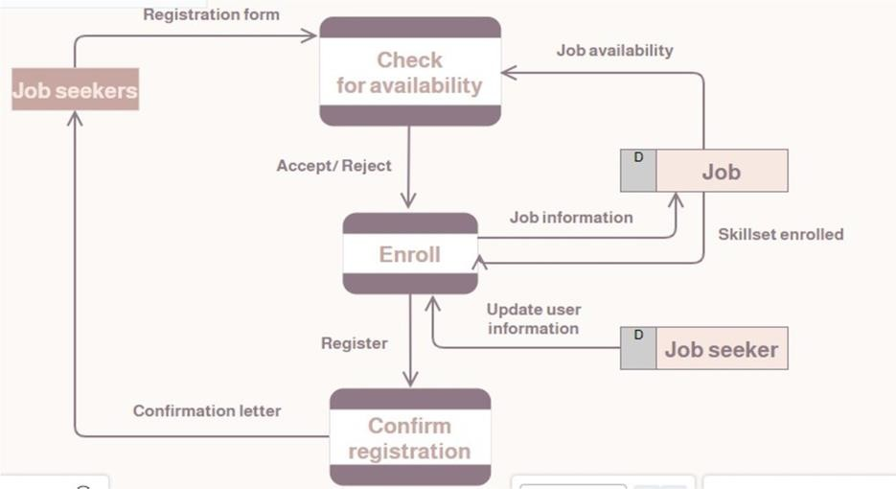

Figure 5.1.1 Data Flow Diagram

A data flow diagram is graphical tool used to describe and analyze movement of data through a system. These are the central tool and the basis from which the other components are developed. The transformation of data from input to output, through processed, may be described logically and independently of physical components associated with the system. These are known as the logical data flow diagrams.

The physical data flow diagrams show the actual implements and movement of data between people, departments and workstations. A full description of a system actually consists of a set of data flow diagrams. Using two familiar notations Yourdon, Gane and Sarson notation develops the data flow diagrams. Each component in a DFD is labeled with a

descriptive name. Process is further identified with a number that will be used for identification purpose.

The development of DFD’S is done in several levels. Each process in lower level diagrams can be broken down into a more detailed DFD in the next level. The lop-level diagram is often called context diagram. It consists a single process bit, which plays vital role in studying the current system. The process in the context level diagram is exploded into other process at the first level DFD.

The idea behind the explosion of a process into more process is that understanding at one level of detail is exploded into greater detail at the next level. This is done until further explosion is necessary and an adequate amount of detail is described for analyst to understand the process.

Larry Constantine first developed the DFD as a way of expressing system requirements in a graphical from, this lead to the modular design.

A DFD is also known as a “bubble Chart” has the purpose of clarifying system requirements and identifying major transformations that will become programs in system design. So it is the starting point of the design to the lowest level of detail. A DFD consists of a series of bubbles joined by data flows in the system.

### DFD SYMBOLS:

In the DFD, there are four symbols,

* + 1. A square defines a source(originator) or destination of system data
    2. An arrow identifies data flow. It is the pipeline through which the information flows
    3. A circle or a bubble represents a process that transforms incoming data flow into outgoing data flows.
    4. An open rectangle is a data store, data at rest or a temporary repository of data.

### CONSTRUCTING A DFD:

Several rules of thumb are used in drawing DFD’S:

1. Process should be named and numbered for an easy reference. Each name should be representative of the process.
2. The direction of flow is from top to bottom and from left to right. Data traditionally flow from source to the destination although they may flow back to the source. One way to indicate this is to draw long flow line back to a source. An alternative way is to repeat the source symbol as a destination. Since it is used more than once in the DFD it is marked with a short diagonal.
3. When a process is exploded into lower level details, they are numbered.
4. The names of data stores and destinations are written in capital letters. Process and dataflow names have the first letter of each work capitalized

A DFD typically shows the minimum contents of data store. Each data store should contain all the data elements that flow in and out.

Questionnaires should contain all the data elements that flow in and out. Missing interfaces redundancies and like is then accounted for often through interviews.

### SAILENT FEATURES OF DFD’S

1. The DFD shows flow of data, not of control loops and decision are controlled considerations do not appear on a DFD.
2. The DFD does not indicate the time factor involved in any process whether the dataflow take place daily, weekly, monthly or yearly.
3. The sequence of events is not brought out on the DFD.

**TYPES OF DATA FLOW DIAGRAMS**

1. Current Physical
2. Current Logical
3. New Logical
4. New Physical

**CURRENT PHYSICAL:**

In Current Physical DFD proecess label include the name of people or their positions or the names of computer systems that might provide some of the overall system-processing label includes an identification of the technology used to process the data. Similarly data flows and data stores are often labels with the names of the actual physical media on which data are stored such as file folders, computer files, business forms or computer tapes.

### CURRENT LOGICAL:

The physical aspects at the system are removed as mush as possible so that the current system is reduced to its essence to the data and the processors that transform them regardless of actual physical form.

### NEW LOGICAL:

This is exactly like a current logical model if the user were completely happy with he user were completely happy with the functionality of the current system but had problems with how it was implemented typically through the new logical model will differ from current logical model while having additional functions, absolute function removal and inefficient flows recognized.

### NEW PHYSICAL:

The new physical represents only the physical implementation of the new system.

**RULES GOVERNING THE DFD’S**

**PROCESS**

1. No process can have only outputs.
2. No process can have only inputs. If an object has only inputs than it must be a sink.
3. A process has a verb phrase label.

### DATA STORE

1. Data cannot move directly from one data store to another data store, a process must move data.
2. Data cannot move directly from an outside source to a data store, a process, which receives, must move data from the source and place the data into data store
3. A data store has a noun phrase label.

### SOURCE OR SINK

The origin and /or destination of data.

1. Data cannot move direly from a source to sink it must be moved by a process
2. A source and /or sink has a noun phrase land

**DATA FLOW**

1. A Data Flow has only one direction of flow between symbols. It may flow in both directions between a process and a data store to show a read before an update. The later is usually indicated however by two separate arrows since these happen at different type.
2. A join in DFD means that exactly the same data comes from any of two or more different processes data store or sink to a common location.
3. A data flow cannot go directly back to the same process it leads. There must be atleast one other process that handles the data flow produce some other data flow returns the original data into the beginning process.
4. A Data flow to a data store means update (delete or change).
5. A data Flow from a data store means retrieve or use.
   1. **SOLUTION & TECHNICAL ARCHITECTURE**

A solution architecture (SA) is an architectural description of a specific solution. SAs combine guidance from different enterprise architecture viewpoints (business, information and technical), as well as from the enterprise solution architecture (ESA).

The solution architecture helps ensure that a new system will fit the existing enterprise environment. To perform this task, a solution architect has to understand how all parts of the business model work together including processes, operating systems, and application architectures

Design solutions that mesh ideally with an enterprise environment. Recommend best practices for the entire solution. Comply with all technical and business requirements. Scrutinize project constraints to analyze alternatives, mitigate risks, and conduct process re-engineering as necessary.

Based on the complexity of the deployment, a solution architecture diagram may actually be a set of diagrams documenting various levels of the architecture. The diagram relates the information that you gather on the environment to both physical and logical choices for your architecture in an easily understood manner.

Solution Architects are most similar to project managers, ensuring that all parties, including stakeholders, are on the same page and moving in the right direction at all stages. Technical architects manage all activities leading to the successful implementation of a new application.

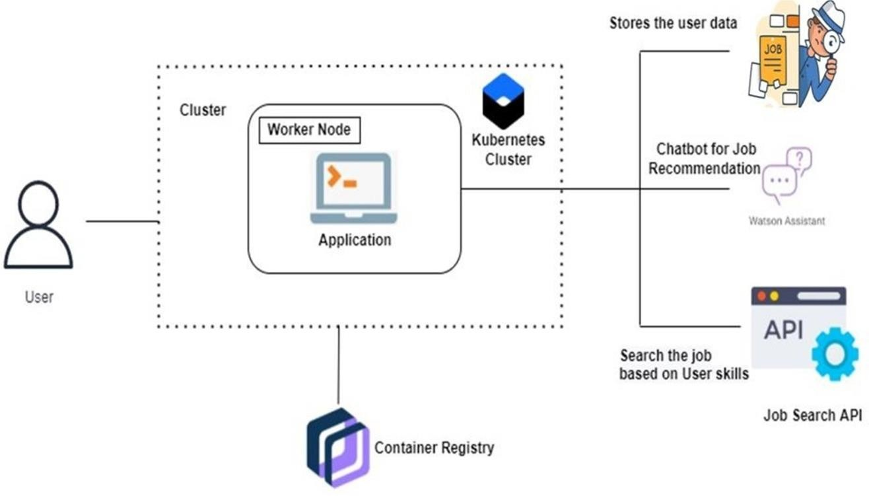

Figure 5.2.1 Solution and Technical Architecture

Based on the complexity of the deployment, a solution architecture diagram may actually be a set of diagrams documenting various levels of the architecture. The diagram relates the information that you gather on the environment to both physical and logical choices for your architecture in an easily understood manner.

|  |  |  |  |
| --- | --- | --- | --- |
| **S**  **.**  **N**  **o** | **Component** | **Description** | **Technology** |
| 1  . | User Interface | User interacts with application  e.g. Mobile  App, webapplication. | Python, C |
| 2  . | Application Logic-1 | Developing application | Python |

|  |  |  |  |
| --- | --- | --- | --- |
| 3  . | Application Logic-2 | To add speech transcription capabilities to application. | IBM Watson STT service |
| 4  . | Application Logic-3 | To automate  interactionswith customers | IBM Watson Assistant |
| 5  . | Database | To create database | MySQL,  NoSQL, etc. |

Table 5.2.1 Components and Technologies

* 1. **USER STORIES**

A user story is an informal, general explanation of a software feature written from the perspective of the end user or customer. The purpose of a user story is to articulate how a piece of work will deliver a particular value back to the customer.

|  |  |  |  |  |  |  |
| --- | --- | --- | --- | --- | --- | --- |
| **User Type** | **Function al Require**  **ment (Epic)** | **User Stor y**  **Number** | **User Story / Task** | **Acceptance criteria** | **Priority** | **Releas e** |
|  | Registration | USN-1 | As a user, I can | I can access my | High | Sprint-1 |
|  |  | register for the  application by | account /dashboard |  |  |
|  |  | entering my email, |  |  |  |
|  |  | password, and |  |  |  |
|  |  | confirmingmy |  |  |  |
|  |  | password. |  |  |  |
|  |  | USN-2 | As a user, I will | I can receive | High | Sprint-1 |
|  | receive confirmation | confirmation |  |  |
|  | email | email & click confirm |  |  |
|  | once I have |  |  |  |
|  | registered for the |  |  |  |
|  | application |  |  |  |
|  |  | USN-3 | As a user, I can | I can register & | Low | Sprint-2 |
|  | register for the | access thedashboard |  |  |
|  | application | with Facebook |  |  |
|  | through | Login |  |  |
|  | Facebook |  |  |  |
|  |  | USN-4 | As a user, I can register for the |  | Medium | Sprint-1 |

|  |  |  |  |  |  |  |
| --- | --- | --- | --- | --- | --- | --- |
|  |  |  | application through Gmail |  |  |  |
|  | Login | USN-5 | As a user, I can log into the application by  entering email & password |  | High | Sprint-1 |
|  | Dashboard | USN -6 | As a user we can  access the dashboard |  | high | Spirit-2 |
| Cust omer (We b  user) |  |  |  |  |  |  |
| Cust ome r Car e Exe cutiv  e |  |  |  |  |  |  |
| Admin  istrato r |  |  |  |  |  |  |

Table 5.3.1 User Stories Template

### CHAPTER – 6

**PROJECT PLANNING & SCHEDULING**

Project design is an early phase of the project lifecycle where ideas, processes, resources, and deliverables are planned out. A project design comes before a project plan as it's a broad overview whereas a project plan includes more detailed information.

### Sprint Planning & Estimation

|  |  |  |  |
| --- | --- | --- | --- |
| **S.NO** | **ACTIVITY TITLE** | **ACTIVITY DESCRIPTION** | **Duration** |
| 1 | Project preparation | Assign team members, Create repository in the GitHub, download rocket-chat essentials and join respective project channel. | 1 WEEK |
| 2 | Attend class | Attend sessions on IBM, team leader assign task to each member of the project, attend quiz , submit assignment. | 1 WEEK |
| 3 | Working on different phases of project | Ideation phase-literature survey, Project design phase I- proposed solution, solution architecture, project design phase II-customer journey  ,data flow ,technical architecture, planning phase- milestones, tasks, sprint schedule. | 4 WEEK |
| 4 | Developing project | Develop the code, test and  push it to GitHub, clarify queries. | 2 WEEK |
| 5 | Budget and scope of project | Analyze and making the project budget and discuss with team for budget  prediction . | 1 WEEK |

Table 6.1.1 Sprint planning & Estimation

* 1. **Sprint Delivery Schedule**

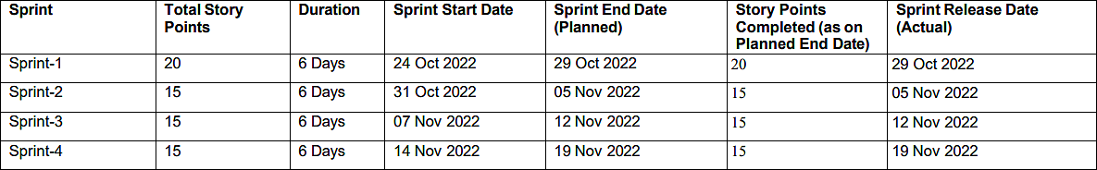

Table 6.2.1 Sprint Delivery Schedule

* 1. **Reports From JIRA**

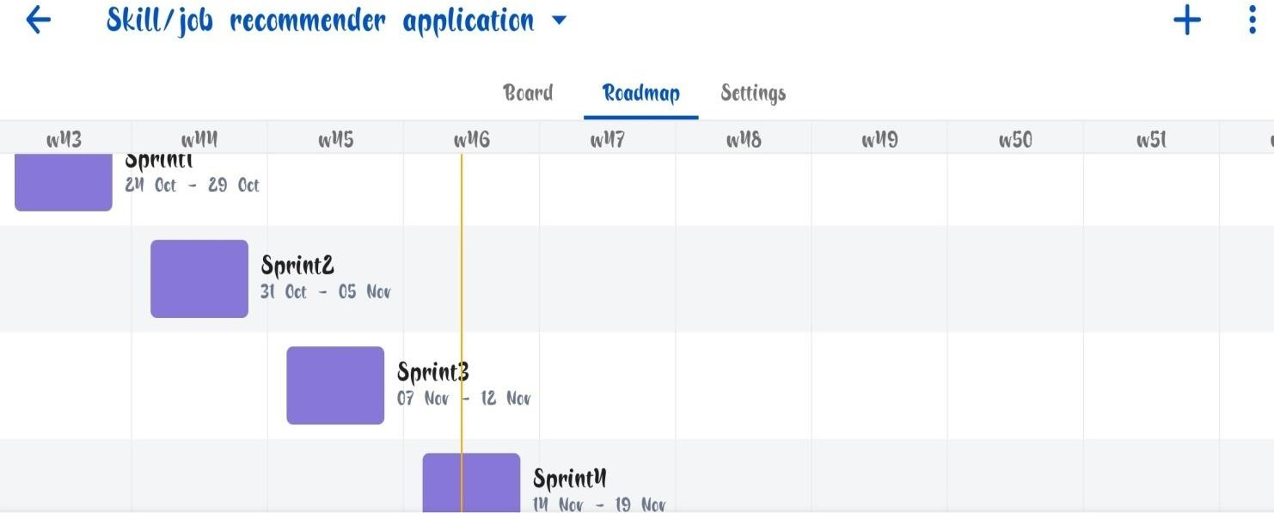

Figure 6.3.1 Reports from JIRA

**CHAPTER - 7**

**CODING & SOLUTIONING (Explain the features added in the project along with code)**

* 1. **Feature 1**

**Software Requirement Specification (SRS)**

The software, Site Explorer is designed for management of web sites from a remote location. The main purpose for preparing this document is to give a general insight into the analysis and requirements of the existing system or situation andfor determining the operating characteristics of the system.

**Scope:** This Document plays a vital role in the development life cycle (SDLC) andit describes the complete requirement of the system. It is meant for use by the developers and will be the basic during testing phase. Any changes made to the requirements in the future will have to go through formal change approval process.

**DEVELOPERS RESPONSIBILITIES OVERVIEW:**

The developer is responsible for:

* Developing the system, which meets the SRS and solving all the requirementsof the system?
* Demonstrating the system and installing the system at client's location after theacceptance testing is successful.
* Submitting the required user manual describing the system interfaces to workon it and also the documents of the system.
* Conducting any user training that might be needed for using the system.
* Maintaining the system for a period of one year after installation.
* To provide a consistent object-oriented programming environment whether object code is stored and executed locally, executed locally but Internet- distributed, or executed remotely.
* To provide a code-execution environment that minimizes software

deployment and versioning conflicts.

* To provide a code-execution environment that guarantees safe execution of code, including code created by an unknown or semi-trusted third party.
* To provide a code-execution environment that eliminates the performance problems of scripted or interpreted environments.
* To make the developer experience consistent across widely varying types of applications, such as Windows-based applications and Web-basedapplications.
* To build all communication on industry standards to ensure that code based on the .NET Framework can integrate with any other code.

The .NET Framework has two main components: the common language runtime and the .NET Framework class library. The common language runtime is the foundation of the .NET Framework. You can think of the runtime as an agent that manages code at execution time, providing core services such as memory management, thread management, and Remoting, while also enforcing strict type safety and other forms of code accuracy that ensure security and robustness. In fact, the concept of code management is a fundamental principle of the runtime. Code that targets the runtime is known as managed code, while code that does not target the runtime is known as unmanaged code

**User Login Form**

<!DOCTYPE html>

<html lang="en">

<head>

<meta charset="UTF-8">

<meta name="viewport" content="width=device-width, initial-scale=1.0">

<meta http-equiv="X-UA-Compatible" content="ie=edge">

<link rel="stylesheet" href="https://cdnjs.cloudflare.com/ajax/libs/meyer-

reset/2.0/reset.min.css">

<title>Register | Flask</title>

<!-- Latest compiled and minified CSS -->

<link

rel="stylesheet"

href="https://maxcdn.bootstrapcdn.com/bootstrap/3.3.7/css/bootstrap.min.css" integrity="sha384- BVYiiSIFeK1dGmJRAkycuHAHRg32OmUcww7on3RYdg4Va+PmSTsz/K68vbd

Ejh4u" crossorigin="anonymous">

<!-- Optional theme -->

<link

rel="stylesheet"

href="https://maxcdn.bootstrapcdn.com/bootstrap/3.3.7/css/bootstrap-

theme.min.css"

integrity="sha384-

rHyoN1iRsVXV4nD0JutlnGaslCJuC7uwjduW9SVrLvRYooPp2bWYgmgJQIXwl

/Sp" crossorigin="anonymous">

</head>

<body>

<div class="container">

<div class="row" style="margin-top: 40px">

<div class="col-sm-6">

<form method="POST">

<div class="form-group">

<label for="email">Username : </label>

<input type="text" name="uname" class="form-control"

id="uname">

</div>

<div class="form-group">

<label for="email">Email : </label>

<input type="email" name="mail" class="form-control" id="mail">

</div>

<div class="form-group">

<label for="email">Password : </label>

<input type="password" name="passw" class="form-control"

id="passw">

</div>

</div>

</div>

<button type="submit" class="btn form-control btn-

default">Register</button>

</form>

</div>

<!-- Latest compiled and minified JavaScript -->

<script src="https://maxcdn.bootstrapcdn.com/bootstrap/3.3.7/js/bootstrap.min.js" integrity="sha384- Tc5IQib027qvyjSMfHjOMaLkfuWVxZxUPnCJA7l2mCWNIpG9mGCD8wGNIc PD7Txa" crossorigin="anonymous"></script>

</body>

</html>

**USER REGISTER FORM**

<!DOCTYPE html>

<html lang="en">

<head>

<meta charset="UTF-8">

<meta name="viewport" content="width=device-width, initial-scale=1.0">

<meta http-equiv="X-UA-Compatible" content="ie=edge">

<link rel="stylesheet" href="https://cdnjs.cloudflare.com/ajax/libs/meyer-

reset/2.0/reset.min.css">

<title>Register | Flask</title>

<!-- Latest compiled and minified CSS -->

<link

rel="stylesheet"

href="https://maxcdn.bootstrapcdn.com/bootstrap/3.3.7/css/bootstrap.min.css"

integrity="sha384-

BVYiiSIFeK1dGmJRAkycuHAHRg32OmUcww7on3RYdg4Va+PmSTsz/K68vbd Ejh4u" crossorigin="anonymous">

<!-- Optional theme -->

<link "

rel="stylesheet

href="https://maxcdn.bootstrapcdn.com/bootstrap/3.3.7/css/bootstrap- theme.min.css"

integrity="sha384

-

rHyoN1iRsVXV4nD0JutlnGaslCJuC7uwjduW9SVrLvRYooPp2bWYgmgJQIXwl

/Sp" crossorigin="anonymous">

</head>

<body>

<div class="container">

<div class="row" style="margin-top: 40px">

<div class="col-sm-6">

<form method="POST">

<div class="form-group">

<label for="email">Username : </label>

<input type="text" name="uname" class="form-control"

id="uname">

</div>

<div class="form-group">

<label for="email">Email : </label>

<input type="email" name="mail" class="form-control" id="mail">

</div>

<div class="form-group">

<label for="email">Password : </label>

<input type="password" name="passw" class="form-control"

id="passw">

</div>

<button type="submit" class="btn form-control btn- default">Register</button>

</form>

</div>

</div>

</div>

<!-- Latest compiled and minified JavaScript -->

<script src="https://maxcdn.bootstrapcdn.com/bootstrap/3.3.7/js/bootstrap.min.js" integrity="sha384- Tc5IQib027qvyjSMfHjOMaLkfuWVxZxUPnCJA7l2mCWNIpG9mGCD8wGNIc PD7Txa" crossorigin="anonymous"></script>

</body>

</html>

* 1. **Feature 2**

The common language runtime manages memory, thread execution, code execution, code safety verification, compilation, and other system services. These features are intrinsic to the managed code that runs on the common language runtime.

With regards to security, managed components are awarded varying degrees of trust, depending on a number of factors that include their origin (such as the Internet, enterprise network, or local computer). This means that a managed component might or might not be able to perform file-access operations, registry- access operations, or other sensitive functions, even if it is being used in the same

active application.

The runtime enforces code access security. For example, users can trust that an executable embedded in a Web page can play an animation on screen or sing a song, but cannot access their personal data, file system, or network. The security features of the runtime thus enable legitimate Internet-deployed software to be exceptionally featuring rich.

The runtime also enforces code robustness by implementing a strict type- and code-verification infrastructure called the common type system (CTS). The CTS ensures that all managed code is self-describing. The various Microsoft and third-party language compilers

Generate managed code that conforms to the CTS. This means that managed code can consume other managed types and instances, while strictly enforcing type fidelity and type safety.

In addition, the managed environment of the runtime eliminates many common software issues. For example, the runtime automatically handles object layout and manages references to objects, releasing them when they are no longer being used. This automatic memory management resolves the two most common application errors, memory leaks and invalid memory references.

The runtime also accelerates developer productivity. For example, programmers can write applications in their development language of choice, yet take full advantage of the runtime, the class library, and components written in other languages by other developers. Any compiler vendor who chooses to targetthe runtime can do so. Language compilers that target the .NET Framework make the features of the .NET Framework available to existing code written in thatlanguage, greatly easing the migration process for existing applications.

### .NET FRAMEWORK CLASS LIBRARY

The .NET Framework class library is a collection of reusable types that tightly integrate with the common language runtime. The class library is object oriented, providing types from which your own managed code can derive functionality. This not only makes the .NET Framework types easy to use, but also reduces the time associated with learning new features of the .NET Framework. In addition, third-party components can integrate seamlessly with classes in the .NET Framework.

For example, the .NET Framework collection classes implement a set of interfaces that you can use to develop your own collection classes. Your collection classes will blend seamlessly with the classes in the .NET Framework.

As you would expect from an object-oriented class library, the .NET Framework types enable you to accomplish a range of common programming tasks, including tasks such as string management, data collection, database connectivity, and file access. In addition to these common tasks, the class library includes types that support a variety of specialized development scenarios.

For example, the Windows Forms classes are a comprehensive set of reusable types that vastly simplify Windows GUI development. If you write an ASP.NET Web Form application, you can use the Web Forms classes.

**CHAPTER - 8** **TESTING**

**8.1 Test Cases**

Software testing is a critical element of software quality assurance and represents the ultimate review of specification, design and coding. In fact, testing is the one step in the software engineering process that could be viewed as destructive rather than constructive.

A strategy for software testing integrates software test case design methods into a well-planned series of steps that result in the successful construction of software. Testing is the set of activities that can be planned in advance and conducted systematically. The underlying motivation of program testing is to affirm software quality with methods that can economically and effectively apply to both strategic to both large and small-scale systems.

**8.2. User Acceptance Testing**

The software engineering process can be viewed as a spiral. Initially system engineering defines the role of software and leads to software requirement analysis where the information domain, functions, behavior, performance, constraints and validation criteria for software are established. Moving inward along the spiral, we come to design and finally to coding. To develop computer software we spiral in along streamlines that decrease the level of abstraction on each turn.

Unit testing focuses verification effort on the smallest unit of software design, the module. The unit testing we have is white box oriented and some modules the steps are conducted in parallel.

1. **WHITE BOX TESTING**

This type of testing ensures that

* All independent paths have been exercised at least once
* All logical decisions have been exercised on their true and false sides
* All loops are executed at their boundaries and within their operational bounds
* All internal data structures have been exercised to assure their validity.

To follow the concept of white box testing we have tested each form .we have created independently to verify that Data flow is correct, All conditions are exercised to check their validity, All loops are executed on their boundaries.

1. **BASIC PATH TESTING**

Established technique of flow graph with Cyclomatic complexity was used to derive test cases for all the functions. The main steps in deriving test cases were:

Use the design of the code and draw correspondent flow graph.

Determine the Cyclomatic complexity of resultant flow graph, using formula: V(G)=E-N+2 or

V(G)=P+1 or

V(G)=Number Of Regions

Where V(G) is Cyclomatic complexity,E is the number of edges,

N is the number of flow graph nodes,P is the number of predicate nodes. Determine the basis of set of linearly independent paths.

1. **CONDITIONAL TESTING**

In this part of the testing each of the conditions were tested to both true and false aspects. And all the resulting paths were tested. So that each path that may be generate on particular condition is traced to uncover any possible errors.

1. **DATA FLOW TESTING**

This type of testing selects the path of the program according to the location of definition and use of variables. This kind of testing was used only when some local variable were declared. The *definition-use chain* method was used in this type of testing. These were particularly useful in nested statements.

1. **LOOP TESTING**

In this type of testing all the loops are tested to all the limits possible. The following exercise was adopted for all loops:

* All the loops were tested at their limits, just above them and just below them.
* All the loops were skipped at least once.
* For nested loops test the inner most loop first and then work outwards.
* For concatenated loops the values of dependent loops were set with the help ofconnected loop.
* Unstructured loops were resolved into nested loops or concatenated loops andtested as above.

Each unit has been separately tested by the development team itself and all the input have been validated.

**CHAPTER - 9** **RESULTS**

**9.1. Performance Metrics**

In the world that we live today, problems like unemployment and employee churn have shown tremendous increase due to the recent and ongoing pandemic situation where companies either lay-off some of their workers or people leave their jobs to be with their families. In such cases, many people are seen surfing online for finding relevant jobs based on their skills with the internet being an essentialemployment resource for many of today’s job seekers. This is where a Job Recommendation System plays an important role.

**CHAPTER - 10** **ADVANTAGES & DISADVANTAGES**

**ADVANTAGES**

It can speak volumes for a candidate-in-question when they are referred by an existing employee. Not only will the current employee, the referrer, likely want to add to and not detract from company culture, but they’ll also vouch for required skillsets and competencies. Here are the top advantages of employee referrals:

1. **Your company will save time and money.**

Sourcing candidates requires a lot of effort, which means it can cost a company both time and money. It was found in one study that referred candidates are 55% faster to hire, compared with employees sourced through career sites. An advantage of employee referrals is that your current team member makes the connection and saves the recruiter that initial time of sourcing the candidate.

Further, the candidate could be a better match compared to other candidates who apply externally. This will also help expedite the process and cut back on the needto find alternative options.

1. **Your company will receive qualified, quality candidates.**

Employees will want to work with someone who will improve their own output and day-to-day workload. So, in most cases, you can have more confidencein the candidate’s ability to perform the necessary tasks. Further, according to research done by Zao, nearly three in ten employers have caught a fake reference on an application. So, a personal recommendation that is already within the company can instill confidence that the reference is in fact valid and reputable.

1. **Retention rate is typically better.**

After two years, retention of referred employees is 45% compared to 20% from job boards. Employee referrals tend to stay around longer, perhaps because they are personally connected to their peers. That’s not to mention that the referrer themselves may feel more respected and valued too after their company takes their recommendation. And when an employee feels respected and valued, they can become more dedicated in turn. You may also want to give an employee referrer a bonus to show your appreciation.

**DISADVANTAGES**

The disadvantages of employee referrals do not outweigh the benefits, but there are still some to consider. Here are three employee referrals disadvantages to keep in mind when making a hiring decision:

1. **You may get a recommendation based on bias.**

While in most cases an employee’s motives should be “pure,” there may be circumstances where a person wants to just work with their friend or receive the referral bonus. This can result in the candidate not being as qualified as either the referrer or referee said they were. The referrer may think that they can make up for the candidate’s shortcomings or give them a crash course to level-set their skills. This can impact their own production in a negative way. And now your company may have two underperforming employees—and you may have to look to fill both of these positions in the not-so-far-off future.

1. **Employee referrals can invite opportunity for negative company politics.**

While an advantage of employee referrals is that they+ can positively impact peer morale, they can also cause unnecessary tension. The twosome can be negatively received by their peers especially if the external hire was chosen over an

internal promotion. Further, the referrer may be afraid to offer critique to the person they referred. This kind of dynamic can negatively impact their work.

1. **Your company could end up losing both the referrer and the referee.**

When one goes, the other may follow. Whether one decides to leave because of company politics, personal reasons, or a better opportunity, there is arisk that their counterpart will follow suit. This chance may heighten if problems with team dynamics aren’t addressed and resolved. So, it’s important to stay involved with a new hire, beyond any initial onboarding and ensure they are connected to the company and not just the employee who referred them.

**CHAPTER – 11** **CONCLUSION**

Recommender systems are a powerful new technology for extracting

additional value for a business from its user databases. These systems help users find items they want to buy from a business. Recommender systems benefit usersby enabling them to find items they like. Conversely, they help the business by generating more sales. Recommender systems are rapidly becoming a crucial toolin E-commerce on the Web. Recommender systems are being stressed by the huge volume of user data in existing corporate databases, and will be stressed even more by the increasing volume of user data available on the Web. New technologies are needed that can dramatically improve the scalability of recommender systems.

**CHAPTER - 12** **FUTURE SCOPE**

Future works in the case of Personalized Job Recommendation Systems are the utilization of the user-preferred location to get job recommendations based on jobs in organizations established in nearby areas. This can be done by extracting the latitudes and longitudes of the user-preferred location and computing the euclidean distances between the latitudes and longitudes of the organization location. This filters out other jobs that fall far from the user-preferred location and gives a more accurate job recommendation.

**CHAPTER - 13** **APPENDIX**

### Source Code Login form design code

<!DOCTYPE html>

<head>

<title>Login Form Design</title>

<link rel="stylesheet" type="text/css" href="style.css">

</head>

<body>

<div class="box">

<img src="user.jpeg" class="user">

<h1>Login Here</h1>

<form name="myform" action="login.php" method="POST" >

<p>Username</p>

<input type="text" name="uname" placeholder="Enter Username " required="">

<p>Password</p>

<input type="password" name="upswd" placeholder="Enter Password" required="">

<input type="submit" name="" value="Login">

<br><br>

<a href="register.html">Register for new account

?</a>

</form>

</div>

</body>

</html>

### Register Login Code

<!DOCTYPE html>

<head>

<title>Register Form Design</title>

<link rel="stylesheet" type="text/css" href="style.css">

<body>

<div class="box">

<img src="user.jpeg" class="user">

<h1>Register Here</h1>

<form name="myform2" action="register.php" method="POST">

<p>Username</p>

<input type="text" name="uname1" placeholder="Enter Username" required="">

<p>Email</p>

<input type="Email" name="email" placeholder="Enter email id" required="">

<p>Password</p>

<input type="password" name="upswd1" placeholder="Enter Password" required="">

<p>Retype Password</p>

<input type="password" name="upswd2" placeholder="Re-Enter Password" required="">

<input type="submit" name="" value="Register">

<br><br>

<a href="index.html">existing user, login !?</a>

</form>

</div>

</body>

</head>

</html>

### Source code

<!DOCTYPE html>

<html>

<head>

<meta charset="utf-8">

<meta name="viewport" content="width=device- width, initial-scale=1">

<title>result</title>

<script type="text/javascript" src="script.js"></script>

<script src="https://cdn.jsdelivr.net/npm/chart.js"></script>

</head>

<body>

<canvas id="myChart" ></canvas>

<script type="text/javascript"> function myFunction() {

var a = document.getElementById('sm1').value;

var b = document.getElementById('sm2').value; var c = document.getElementById('sm3').value; var d = document.getElementById('it1').value; var e = document.getElementById('it2').value; var f = document.getElementById('it3').value; var g =document.getElementById('tran1').value; var h = document.getElementById('tran2').value; var i = document.getElementById('tran3').value; var j = document.getElementById('dev1').value; var k = document.getElementById('dev2').value;

var l = document.getElementById('dev3').value; var m = document.getElementById('cre1').value; var n = document.getElementById('cre2').value; var o = document.getElementById('cre3').value; var sm =parseInt(a)+parseInt(b)+parseInt(c);

var ite =parseInt(d)+parseInt(e)+parseInt(f); var trns =parseInt(g)+parseInt(h)+parseInt(i); var deve =parseInt(a)+parseInt(b)+parseInt(c); var des =parseInt(m)+parseInt(n)+parseInt(o);

var grp=[sm,ite,trns,deve,des,grp];

const ctx = document.getElementById('myChart'); const myChart = new Chart(ctx, {

type: 'bar', data: {

labels: ['Sales&Marketing', 'IT&Engineering', 'Translation', 'Development', 'Designing'],

datasets: [{

label: 'RESULTS', data: grp, backgroundColor: [

'rgba(255, 99, 132, 0.2)',

'rgba(54, 162, 235, 0.2)',

'rgba(255, 206, 86, 0.2)',

'rgba(75, 192, 192, 0.2)',

'rgba(153, 102, 255, 0.2)',

'rgba(255, 159, 64, 0.2)'

],

borderColor: [

'rgba(255, 99, 132, 1)',

'rgba(54, 162, 235, 1)',

'rgba(255, 206, 86, 1)',

'rgba(75, 192, 192, 1)',

'rgba(153, 102, 255, 1)',

'rgba(255, 159, 64, 1)'

],

borderWidth: 1

}]

},

options: { scales: {

y: {

beginAtZero: true

}

}

}

});

var button = document.createElement("button"); button.innerHTML = "GET JOB RECOMMENDATION";

// 2. Append somewhere

var body = document.getElementsByTagName("body")[0]; body.appendChild(button);

// 3. Add event handler

button.addEventListener ("click", function() {if (sm>ite && sm>trns && sm>deve && sm>des)

{

window.open("https://[www.naukri.com/sales](http://www.naukri.com/sales)-jobs");

}

else if (ite>sm && ite>trans && ite>deve && ite>des)

{

window.open("https://[www.naukri.com/it](http://www.naukri.com/it)-jobs");

}

else if (trns>sm && trns>ite && trns>deve && trns>des)

{

window.open("https://[www.naukri.com/translation](http://www.naukri.com/translation)-jobs");

}

else if (deve>sm && deve>ite && deve>trns && deve>des)

{

window.open("https://[www.naukri.com/development](http://www.naukri.com/development)-jobs");

}

else

{

window.open("https://[www.naukri.com/designing](http://www.naukri.com/designing)-jobs");

}

});

}

</script>

</body>

</html>

<!DOCTYPE html>

<html>

<head>

<meta charset="utf-8">

<meta name="viewport" content="width=device-width, initial- scale=1">

<title></title>

<script type="text/javascript" src="script.js"></script>

<script src="https://cdn.jsdelivr.net/npm/chart.js"></script>

</head>

<body>

<center><h1>COUNSELLING TEST</h1></center>

<div>

<label >1)HOW GOOD ARE YOU IN CLIENT

RELATIONSHIP?</label><br>

<input type="range" id="sm1" name="vol" min="0" max="33.3" value="0"><br><br>

<label >2)HOW GOOD ARE YOU IN PRESENTATION?</label><br>

<input type="range" id="sm2" name="vol" min="0" max="33.3" value="0"><br><br>

<label >3)HOW GOOD ARE YOU IN ACHIEVING

GOASL?</label><br>

<input type="range" id="sm3" name="vol" min="0" max="33.3" value="0"><br><br>

<label >4)HOW GOOD ARE YOU IN COLLABORATING WITH

OTHERS?</label><br>

<input type="range" id="it1" name="vol" min="0" max="33.3" value="0"><br><br>

<label >5)LEVEL OF YOUR PROBLEM SOLVING

SKILLS?</label><br>

<input type="range" id="it2" name="vol" min="0" max="33.3" value="0"><br><br>

<label >6)HOW MUCH DO YOU KNOW ABOUT COMPUTER

LITERACY?</label><br>

<input type="range" id="it3" name="vol" min="0" max="33.3" value="0"><br><br>

<label>7)ABILITY TO GRASP NEW LANGAGE </label><br>

<input type="range" id="tran1" name="vol" min="0" max="33.3" value="0"><br><br>

<label>8)KNOWLEDGE IN SPELLING & GRAMMAAR</label><br>

<input type="range" id="tran2" name="vol" min="0" max="33.3" value="0"><br><br>

<label>9)LANGUAGE FULENCY LEVEL </label><br>

<input type="range" id="tran3" name="vol" min="0" max="33.3" value="0"><br><br>

<label>10)LEVEL OF YOUR KNOWLEDGE IN SOFTWARE DEVELOPMENT LIFECYCLE</label><br>

<input type="range" id="dev1" name="vol" min="0" max="33.3" value="0"><br><br>

<label>11)LEVEL OF YOUR WORK IN FAST PACED

ENVIRONMENT</label><br>

<input type="range" id="dev2" name="vol" min="0" max="33.3" value="0"><br><br>

<label>12)LEVEL OF DOCUMENTATION READING</label><br>

<input type="range" id="dev3" name="vol" min="0" max="33.3" value="0"><br><br>

<label>13)LEVEL OF CREATIVITY</label><br>

<input type="range" id="cre1" name="vol" min="0" max="33.3" value="0"><br><br>

<label>14)FAMILARITY WITH DESING SOFTWARES</label><br>

<input type="range" id="cre2" name="vol" min="0" max="33.3" value="0"><br><br>

<label>15)CREATIVIYTY LEVEL</label><br>

<input type="range" id="cre3" name="vol" min="0" max="33.3" value="0"><br><br>

<button onclick="window.open('graph.html');">submit</button>

</body>

</html>

### GitHub & Project Demo Link

GitHub Link: [**https://github.com/IBM-EPBL/IBM-Project-43726-1660719031**](https://github.com/IBM-EPBL/IBM-Project-43726-1660719031)

Project Demo Link:

[**https://drive.google.com/file/d/1e_euCnQaEXUJdpiormk9AVTXpk4Ujop2/view?usp=share_lin**](https://drive.google.com/file/d/1e_euCnQaEXUJdpiormk9AVTXpk4Ujop2/view?usp=share_link)[**k**](https://drive.google.com/file/d/1e_euCnQaEXUJdpiormk9AVTXpk4Ujop2/view?usp=share_link)